LOVELY PROFESSIONAL UNIVERSITY
PROJECT / PRACTICAL FILE
BANKING TRANSACTION NETWORK
Directed-Graph Analysis of Customer Money Transfers
Submitted by: | Saransh Singh
Registration No.: | 12301472
Roll No.: | 35
Section: | RK2P23FHB36
Course / Subject:
Submitted to:
Date: | 02 November 2026

1. Introduction
Banks process millions of money transfers between their customers every day. Looking at these transfers as a network, where customers are points and transfers are arrows between them, makes it possible to see who is most active, who receives money from many different people, and where unusually large amounts move. This project models a banking transaction dataset as a directed graph and analyses it using Python.

1.1 Problem statement
The assigned task is “Banking Transaction Network”. It consists of the following steps:
- Load a dataset of bank transactions between customers.
- Construct a directed graph where nodes are customers and edges represent money transfers.
- Compute the total number of transactions per customer.
- Identify the most active customer in terms of transactions.
- Visualize the transaction network with high-value transactions highlighted.

1.2 Key concepts
Term | Meaning in this project
Node | A customer account (IDs such as C665576141).
Directed edge | One money transfer drawn as an arrow from the sender (nameOrig) to the receiver (nameDest).
Out-degree | Number of transfers a customer has sent.
In-degree | Number of transfers a customer has received.
Transactions per customer | Out-degree + in-degree, i.e. every transfer the customer took part in.
High-value transaction | A transfer whose amount is in the top 5% of all transfer amounts (95th percentile or above).

1.3 Tools and libraries
- Python 3 – programming language.
- pandas – loading the 6.36-million-row CSV and aggregating data.
- NetworkX – building the directed (multi)graph and computing in-/out-degrees.
- Matplotlib and NumPy – network drawing, charts and the dashboard.

1.4 Approach and design decisions
- Edges = TRANSFER transactions. The PaySim file contains five transaction types. Only type TRANSFER represents a customer sending money to another customer, so these 532,909 rows become the edges. The other types (CASH_IN, CASH_OUT, PAYMENT, DEBIT) involve cash points or merchants.
- MultiDiGraph. NetworkX’s MultiDiGraph is used so that every transfer is kept as its own edge, even if the same two customers transact more than once. Then in-degree + out-degree equals the exact number of transactions.
- High-value threshold. Instead of picking an arbitrary number, the 95th percentile of transfer amounts is used (2,674,586.94). It adapts to the data and is easy to change (HIGH_VALUE_PERCENTILE in the code).
- Readable drawing. A graph with 769,775 nodes cannot be drawn legibly, so the picture shows the 10 most active customers together with all their counter-parties (277 customers). All numerical results use the complete dataset.

2. Dataset Link
Dataset: Synthetic Financial Datasets For Fraud Detection (PaySim)
Dataset link: https://www.kaggle.com/datasets/ealaxi/paysim1
File used: PS_20174392719_1491204439457_log_1.csv (about 494 MB, 6,362,620 rows, 11 columns)
PaySim is a simulator of mobile-money transactions generated from real transaction logs of an African financial service. It is synthetic, so it contains no real customer data. One simulated step equals one hour, and the log covers 743 steps (about 31 days). The graph uses the columns below.
Column | Type | Description
step | integer | Time unit: 1 step = 1 hour of simulation.
type | text | CASH_IN, CASH_OUT, DEBIT, PAYMENT or TRANSFER.
amount | decimal | Amount of the transaction (local currency units).
nameOrig | text | Customer who started the transaction (sender) – graph edge source.
nameDest | text | Recipient of the transaction (receiver) – graph edge target.
isFraud | 0 / 1 | Fraud label (loaded but not needed for this task).

Other columns in the file (oldbalanceOrg, newbalanceOrig, oldbalanceDest, newbalanceDest, isFlaggedFraud) are not required for the network and are skipped while loading to save memory.
Transactions by type in the dataset:
Type | Rows | Used in graph?
CASH_OUT | 2,237,500 | No
PAYMENT | 2,151,495 | No
CASH_IN | 1,399,284 | No
TRANSFER | 532,909 | Yes – these are the edges
DEBIT | 41,432 | No
Total | 6,362,620

3. Source Code
File name: banking_transaction_network.py
How to run: install the libraries with pip install pandas networkx matplotlib numpy, keep the CSV in the same folder as the script and run python banking_transaction_network.py. All charts and the summary are saved in a folder named outputs.
The program follows the five steps of the task: Step 1 loads the data, Step 2 builds the directed graph, Step 3 counts transactions per customer, Step 4 finds the most active customer and Step 5 draws the network, the neighbourhood of the most active customer and the dashboard.
# -*- coding: utf-8 -*-
"""
Banking Transaction Network Analysis
====================================
Name : Saransh Singh
Reg. No. : 12301472
Roll No. : 35
Section : RK2P23FHB36
Dataset : PaySim - Synthetic Financial Datasets For Fraud Detection
https://www.kaggle.com/datasets/ealaxi/paysim1

Tasks
1. Load a dataset of bank transactions between customers.
2. Construct a directed graph (nodes = customers, edges = money transfers).
3. Compute the total number of transactions per customer.
4. Identify the most active customer.
5. Visualize the network with high-value transactions highlighted.
"""

import json
import os
import time

import matplotlib
matplotlib.use("Agg") # draw to files (no display needed)
import matplotlib.pyplot as plt
import networkx as nx
import numpy as np
import pandas as pd
from matplotlib.lines import Line2D

# ----------------------------------------------------------------------------
# Settings
# ----------------------------------------------------------------------------
CSV_PATH = "PS_20174392719_1491204439457_log_1.csv"
OUT_DIR = "outputs"
SAMPLE_ROWS = None # use e.g. 1_000_000 on a low-RAM PC; None = all rows
HIGH_VALUE_PERCENTILE = 0.95 # top 5 % of transfer amounts are "high-value"
TOP_N = 10 # most active customers drawn in the network plot

RED, GOLD, BLUE, GREY = "#e03131", "#f59f00", "#1c7ed6", "#adb5bd"
os.makedirs(OUT_DIR, exist_ok=True)

def money(x):
"""Format a number as 1.23B / 4.56M / 789.0K for chart labels."""
if x >= 1e9:
return f"{x / 1e9:,.2f}B"
if x >= 1e6:
return f"{x / 1e6:,.2f}M"
if x >= 1e3:
return f"{x / 1e3:,.1f}K"
return f"{x:,.0f}"

def banner(text):
print("\n" + "=" * 70 + f"\n {text}\n" + "=" * 70)

# ----------------------------------------------------------------------------
# Step 1 - Load the dataset
# ----------------------------------------------------------------------------
def load_dataset(path, nrows=None):
cols = ["step", "type", "amount", "nameOrig", "nameDest", "isFraud"]
dtypes = {"step": "int16", "type": "category",
"amount": "float64", "isFraud": "int8"}
return pd.read_csv(path, usecols=cols, dtype=dtypes, nrows=nrows)

# ----------------------------------------------------------------------------
# Step 2 - Build the directed graph
# ----------------------------------------------------------------------------
def build_graph(transfers):
"""Nodes = customers, directed edge = one money transfer (sender -> receiver).
MultiDiGraph keeps every transfer, even repeated ones between the same pair."""
return nx.from_pandas_edgelist(
transfers, source="nameOrig", target="nameDest",
edge_attr=["amount", "step"], create_using=nx.MultiDiGraph)

# ----------------------------------------------------------------------------
# Step 3 - Transactions per customer
# ----------------------------------------------------------------------------
def transactions_per_customer(G):
sent = dict(G.out_degree()) # transfers made by the customer
received = dict(G.in_degree()) # transfers received by the customer
table = pd.DataFrame({"customer": list(G.nodes())})
table["sent"] = table["customer"].map(sent)
table["received"] = table["customer"].map(received)
table["total_transactions"] = table["sent"] + table["received"]
return (table.sort_values(["total_transactions", "customer"],
ascending=[False, True])
.reset_index(drop=True))

# ----------------------------------------------------------------------------
# Step 5 - Visualisation helpers
# ----------------------------------------------------------------------------
def simple_view(G, nodes, threshold):
"""Collapse parallel edges into one drawable DiGraph.
An edge is 'high' if any transfer on that pair reaches the threshold."""
D = nx.DiGraph()
D.add_nodes_from(nodes)
for u, v, d in G.subgraph(nodes).edges(data=True):
if D.has_edge(u, v):
D[u][v]["amount"] = max(D[u][v]["amount"], d["amount"])
D[u][v]["n"] += 1
else:
D.add_edge(u, v, amount=d["amount"], n=1)
for u, v in D.edges():
D[u][v]["high"] = D[u][v]["amount"] >= threshold
return D

def ring_layout(D, hubs):
"""Place the hubs evenly on a ring; their counter-parties are pulled towards
them by the spring layout, so every hub forms its own readable cluster."""
ring = {h: (1.25 * np.cos(2 * np.pi * i / len(hubs)),
1.25 * np.sin(2 * np.pi * i / len(hubs))) for i, h in enumerate(hubs)}
return nx.spring_layout(D, pos=ring, fixed=hubs, k=0.12, iterations=300, seed=42)

def draw_network(ax, G, table, threshold, top_n=TOP_N, labels=True, small=False):
"""Draw the top-N most active customers plus all of their neighbours."""
hubs = list(table["customer"].head(top_n))
nodes = set(hubs)
for h in hubs:
nodes.update(G.predecessors(h))
nodes.update(G.successors(h))
D = simple_view(G, nodes, threshold)
pos = ring_layout(D, hubs)

total = dict(zip(table["customer"], table["total_transactions"]))
normal = [(u, v) for u, v, d in D.edges(data=True) if not d["high"]]
high = [(u, v) for u, v, d in D.edges(data=True) if d["high"]]

sizes = [(total[n] * (10 if small else 18)) if n in hubs else (6 if small else 14)
for n in D.nodes()]
colors = [GOLD if n == hubs[0] else BLUE if n in hubs else GREY for n in D.nodes()]

nx.draw_networkx_edges(D, pos, edgelist=normal, ax=ax, edge_color="#868e96",
alpha=0.35, width=0.6, arrows=True,
arrowsize=6 if small else 8, node_size=sizes)
nx.draw_networkx_edges(D, pos, edgelist=high, ax=ax, edge_color=RED,
alpha=0.95, width=1.1 if small else 1.9, arrows=True,
arrowsize=8 if small else 13, node_size=sizes)
nx.draw_networkx_nodes(D, pos, ax=ax, node_size=sizes, node_color=colors,
edgecolors="black", linewidths=0.4)
if labels:
for h in hubs: # label on the empty side, towards the centre
x, y = pos[h]
ax.text(x * 0.78, y * 0.78, h, ha="center", va="center", fontsize=8,
fontweight="bold",
bbox=dict(boxstyle="round,pad=0.2", fc="white", ec="none", alpha=0.85))
ax.set_axis_off()
return D, len(high), len(normal)

def network_legend(ax, threshold):
handles = [
Line2D([0], [0], color=RED, lw=2.2,
label=f"High-value transfer (amount >= {money(threshold)})"),
Line2D([0], [0], color="#868e96", lw=1, label="Regular transfer"),
Line2D([0], [0], marker="o", color="w", markerfacecolor=GOLD,
markeredgecolor="black", markersize=11, label="Most active customer"),
Line2D([0], [0], marker="o", color="w", markerfacecolor=BLUE,
markeredgecolor="black", markersize=9, label="Other top customers"),
Line2D([0], [0], marker="o", color="w", markerfacecolor=GREY,
markeredgecolor="black", markersize=6, label="Other customers"),
]
ax.legend(handles=handles, loc="upper center", bbox_to_anchor=(0.5, 0.0),
ncol=3, fontsize=9, frameon=False)

def plot_network(G, table, threshold, path):
fig, ax = plt.subplots(figsize=(11, 8.5))
D, n_high, n_norm = draw_network(ax, G, table, threshold)
network_legend(ax, threshold)
ax.set_title(f"Banking Transaction Network - top {TOP_N} most active customers "
f"and their counter-parties\n({D.number_of_nodes()} customers, "
f"{D.number_of_edges()} connections, {n_high} high-value)",
fontsize=12, fontweight="bold")
fig.savefig(path, dpi=170, bbox_inches="tight")
plt.close(fig)
return D, n_high

def plot_ego(G, customer, threshold, path):
"""Everything the most active customer sent (right) and received (left)."""
D = simple_view(G, set(G.predecessors(customer)) | set(G.successors(customer))
| {customer}, threshold)
senders = sorted(D.predecessors(customer), key=lambda n: -D[n][customer]["amount"])
receivers = sorted(D.successors(customer), key=lambda n: -D[customer][n]["amount"])
if not receivers: # customer only receives money
hub_x, xlim = 0.6, (-1.6, 1.0)
elif not senders: # customer only sends money
hub_x, xlim = -0.6, (-1.0, 1.6)
else:
hub_x, xlim = 0.0, (-1.5, 1.5)
pos = {customer: (hub_x, 0)}
for side, group in ((-1, senders), (1, receivers)):
ys = np.linspace(1, -1, max(len(group), 2))
for n, y in zip(group, ys):
pos[n] = (side, y)

fig, ax = plt.subplots(figsize=(11, 8))
amounts = [d["amount"] for _, _, d in D.edges(data=True)]
widths = {e: 0.6 + 4.0 * np.log10(1 + D.edges[e]["amount"]) / np.log10(1 + max(amounts))
for e in D.edges()}
for e in D.edges():
hv = D.edges[e]["high"]
nx.draw_networkx_edges(D, pos, edgelist=[e], ax=ax, width=widths[e],
edge_color=RED if hv else "#868e96",
alpha=0.95 if hv else 0.45, arrows=True, arrowsize=12,
node_size=300, connectionstyle="arc3,rad=0.05")
nx.draw_networkx_nodes(D, pos, ax=ax, node_size=[1300 if n == customer else 150
for n in D.nodes()],
node_color=[GOLD if n == customer else GREY for n in D.nodes()],
edgecolors="black", linewidths=0.6)
for n, (x, y) in pos.items():
if n == customer:
ax.text(x, y - 0.18, customer, ha="center", fontsize=10, fontweight="bold")
else:
ax.text(x + (-0.04 if x < 0 else 0.04), y, n, fontsize=7,
ha="right" if x < 0 else "left", va="center")
for u, v, d in D.edges(data=True): # amount tag beside each high-value edge
if d["high"]:
other = u if v == customer else v
x, y = pos[other]
ax.text(x + (0.28 if x < 0 else -0.28), y, money(d["amount"]), color=RED,
fontsize=9, fontweight="bold", ha="center", va="center",
bbox=dict(boxstyle="round,pad=0.15", fc="white", ec=RED, lw=0.8))
if senders:
ax.text(-1, 1.18, f"RECEIVED FROM ({len(senders)})", ha="center",
fontweight="bold", fontsize=10)
if receivers:
ax.text(1, 1.18, f"SENT TO ({len(receivers)})", ha="center",
fontweight="bold", fontsize=10)
ax.set_xlim(*xlim)
ax.set_ylim(-1.25, 1.3)
ax.set_axis_off()
network_legend(ax, threshold)
ax.set_title(f"Transaction neighbourhood of the most active customer ({customer})\n"
"edge thickness = transfer amount", fontsize=12, fontweight="bold")
fig.savefig(path, dpi=170, bbox_inches="tight")
plt.close(fig)

def plot_dashboard(G, table, transfers, threshold, summary, path):
with plt.rc_context({"font.size": 11, "axes.titlesize": 13, "axes.labelsize": 11}):
_dashboard(G, table, transfers, threshold, summary, path)

def _dashboard(G, table, transfers, threshold, summary, path):
fig = plt.figure(figsize=(16, 10), facecolor="#f8f9fa")
gs = fig.add_gridspec(3, 3, height_ratios=[0.42, 1.5, 1.5],
hspace=0.55, wspace=0.24, left=0.055, right=0.975,
top=0.90, bottom=0.06)
fig.suptitle("BANKING TRANSACTION NETWORK - DASHBOARD", fontsize=21,
fontweight="bold", y=0.975)

# ---- KPI cards ---------------------------------------------------------
kpis = [("Customers (nodes)", f"{summary['customers']:,}", BLUE),
("Transfers (edges)", f"{summary['transfers']:,}", BLUE),
("Total value moved", money(summary["total_value"]), BLUE),
(f"High-value transfers (>= {money(threshold)})",
f"{summary['high_value_transfers']:,}", RED),
("Most active customer",
f"{summary['most_active']}\n{summary['most_active_total']} transactions", GOLD)]
inner = gs[0, :].subgridspec(1, 5, wspace=0.08)
for i, (label, value, color) in enumerate(kpis):
ax = fig.add_subplot(inner[0, i])
ax.set_facecolor("white")
ax.set_xticks([]); ax.set_yticks([])
for s in ax.spines.values():
s.set_edgecolor(color); s.set_linewidth(2)
ax.text(0.5, 0.64, value, ha="center", va="center", transform=ax.transAxes,
fontsize=18 if "\n" not in value else 13, fontweight="bold", color=color)
ax.text(0.5, 0.17, label, ha="center", va="center", transform=ax.transAxes,
fontsize=9.5, color="#495057")

# ---- 1. distribution of transactions per customer ----------------------
ax = fig.add_subplot(gs[1, 0])
dist = table["total_transactions"].value_counts().sort_index()
ax.bar(dist.index, dist.values, color=BLUE)
ax.set_yscale("log")
ax.set_title("Transactions per customer (distribution)", fontweight="bold")
ax.set_xlabel("Total transactions (sent + received)")
ax.set_ylabel("Number of customers (log scale)")

# ---- 2. top-10 most active customers -----------------------------------
ax = fig.add_subplot(gs[1, 1])
t10 = table.head(10).iloc[::-1]
ax.barh(t10["customer"], t10["sent"], color=BLUE, label="Sent")
ax.barh(t10["customer"], t10["received"], left=t10["sent"], color="#20c997",
label="Received")
for i, tot in enumerate(t10["total_transactions"]):
ax.text(tot + 0.3, i, str(tot), va="center", fontsize=9, fontweight="bold")
ax.set_title("Top 10 most active customers", fontweight="bold")
ax.set_xlabel("Number of transactions")
ax.tick_params(axis="y", labelsize=8)
ax.set_xlim(0, 39) # leave room for the legend
ax.legend(loc="lower right")

# ---- 3. transfer-amount distribution -----------------------------------
ax = fig.add_subplot(gs[1, 2])
bins = np.logspace(0, np.log10(transfers["amount"].max()), 50)
ax.hist(transfers["amount"].clip(lower=1), bins=bins, color="#74c0fc")
ax.hist(transfers.loc[transfers["amount"] >= threshold, "amount"], bins=bins,
color=RED)
ax.axvline(threshold, color="black", ls="--", lw=1.2)
ax.set_xscale("log")
ax.set_title("Transfer amount distribution", fontweight="bold")
ax.set_xlabel("Amount (log scale)")
ax.set_ylabel("Number of transfers")
ax.legend(handles=[Line2D([0], [0], color="#74c0fc", lw=6, label="Regular"),
Line2D([0], [0], color=RED, lw=6, label="High-value"),
Line2D([0], [0], color="black", ls="--",
label=f"Threshold {money(threshold)}")], fontsize=8)

# ---- 4. transfers per day ----------------------------------------------
ax = fig.add_subplot(gs[2, 0])
day = (transfers["step"] - 1) // 24 + 1 # 1 step = 1 hour
hv = transfers["amount"] >= threshold
per_day = pd.DataFrame({"regular": day[~hv].value_counts(),
"high": day[hv].value_counts()}).fillna(0).sort_index()
ax.bar(per_day.index, per_day["regular"], color="#74c0fc", label="Regular")
ax.bar(per_day.index, per_day["high"], bottom=per_day["regular"], color=RED,
label="High-value")
ax.set_title("Transfers per day", fontweight="bold")
ax.set_xlabel("Day of simulation")
ax.set_ylabel("Number of transfers")
ax.legend()

# ---- 5. mini network ----------------------------------------------------
ax = fig.add_subplot(gs[2, 1])
draw_network(ax, G, table, threshold, top_n=TOP_N, labels=False, small=True)
ax.set_title("Network of top customers (red = high-value)", fontweight="bold")

# ---- 6. five largest transfers (table) ---------------------------------
ax = fig.add_subplot(gs[2, 2])
ax.set_axis_off()
ax.set_title("Five largest transfers", fontweight="bold")
big = transfers.nlargest(5, "amount")
cells = [[r.nameOrig, r.nameDest, money(r.amount), f"{(r.step - 1) // 24 + 1}"]
for r in big.itertuples()]
tbl = ax.table(cellText=cells, colLabels=["Sender", "Receiver", "Amount", "Day"],
loc="center", cellLoc="center")
tbl.auto_set_font_size(False)
tbl.set_fontsize(8.5)
tbl.scale(1, 2.1)
for (r, _), cell in tbl.get_celld().items():
if r == 0:
cell.set_facecolor("#343a40")
cell.set_text_props(color="white", fontweight="bold")
else:
cell.set_facecolor("#ffe3e3")

fig.savefig(path, dpi=130, facecolor=fig.get_facecolor())
plt.close(fig)

# ----------------------------------------------------------------------------
# Main program
# ----------------------------------------------------------------------------
def main():
t0 = time.time()
banner("BANKING TRANSACTION NETWORK ANALYSIS")

# ---- Step 1 ------------------------------------------------------------
print("[Step 1] Loading the dataset ...")
df = load_dataset(CSV_PATH, SAMPLE_ROWS)
rows_loaded = len(df)
print(f" File : {CSV_PATH}")
print(f" Rows loaded : {rows_loaded:,}")
print(" Transactions by type :")
for t, c in df["type"].value_counts().items():
print(f" {t:<10} {c:>10,}")
transfers = df[df["type"] == "TRANSFER"].reset_index(drop=True)
print(f" Money transfers used for the graph (type = TRANSFER): {len(transfers):,}")

# ---- Step 2 ------------------------------------------------------------
print("\n[Step 2] Constructing the directed graph ...")
G = build_graph(transfers)
print(f" Graph type : {type(G).__name__} (directed, parallel edges allowed)")
print(f" Nodes (customers) : {G.number_of_nodes():,}")
print(f" Edges (transfers) : {G.number_of_edges():,}")
print(f" Self-loops : {nx.number_of_selfloops(G):,}")

# ---- Step 3 ------------------------------------------------------------
print("\n[Step 3] Total number of transactions per customer (sent + received)")
table = transactions_per_customer(G)
table.to_csv(os.path.join(OUT_DIR, "transactions_per_customer.csv"), index=False)
print(table.head(10).to_string(index=False))
once = int((table["total_transactions"] == 1).sum())
print(f" Customers with exactly 1 transaction : {once:,} "
f"({once / len(table):.1%} of all customers)")
print(f" Average transactions per customer : "
f"{table['total_transactions'].mean():.2f}")

# ---- Step 4 ------------------------------------------------------------
banner("[Step 4] MOST ACTIVE CUSTOMER")
best = table["total_transactions"].max()
leaders = table[table["total_transactions"] == best]
top = leaders.iloc[0]
sent_value = transfers.loc[transfers["nameOrig"] == top.customer, "amount"].sum()
recv_value = transfers.loc[transfers["nameDest"] == top.customer, "amount"].sum()
print(f" Customer ID : {top.customer}")
print(f" Total transactions : {top.total_transactions}")
print(f" Transfers sent : {top.sent} (value {sent_value:,.2f})")
print(f" Transfers received : {top.received} (value {recv_value:,.2f})")
if len(leaders) > 1:
print(f" (tie: {len(leaders)} customers share {best} transactions)")

# Extra check: count every transaction type (merchants 'M...' are not customers)
all_cnt = df["nameOrig"].value_counts().add(df["nameDest"].value_counts(),
fill_value=0)
all_cnt = all_cnt[all_cnt.index.str.startswith("C")].sort_values(ascending=False)
print("\n Extended check - counting ALL five transaction types:")
print(f" most active customer = {all_cnt.index[0]} "
f"with {int(all_cnt.iloc[0])} transactions")
ext_id, ext_total = all_cnt.index[0], int(all_cnt.iloc[0])
del df, all_cnt # free memory - not needed any more

# ---- Step 5 ------------------------------------------------------------
banner("[Step 5] HIGH-VALUE TRANSACTIONS AND VISUALISATION")
threshold = float(transfers["amount"].quantile(HIGH_VALUE_PERCENTILE))
n_high = int((transfers["amount"] >= threshold).sum())
print(f" High-value threshold : {threshold:,.2f} "
f"(top {1 - HIGH_VALUE_PERCENTILE:.0%} of transfer amounts)")
print(f" High-value transfers : {n_high:,}")
print(f" Largest transfer : {transfers['amount'].max():,.2f}")

summary = {
"rows_loaded": int(rows_loaded),
"transfers": int(len(transfers)),
"customers": int(G.number_of_nodes()),
"total_value": float(transfers["amount"].sum()),
"threshold": threshold,
"high_value_transfers": n_high,
"most_active": top.customer,
"most_active_total": int(top.total_transactions),
"most_active_sent": int(top.sent),
"most_active_received": int(top.received),
"once_customers": once,
"extended_most_active": ext_id,
"extended_most_active_total": ext_total,
}

D, n_high_drawn = plot_network(G, table, threshold,
os.path.join(OUT_DIR, "network_graph.png"))
print(f" Saved network_graph.png ({D.number_of_nodes()} customers drawn, "
f"{n_high_drawn} high-value connections in red)")
plot_ego(G, top.customer, threshold, os.path.join(OUT_DIR, "most_active_customer.png"))
print(" Saved most_active_customer.png")
plot_dashboard(G, table, transfers, threshold, summary,
os.path.join(OUT_DIR, "dashboard.png"))
print(" Saved dashboard.png")

with open(os.path.join(OUT_DIR, "summary.json"), "w") as f:
json.dump(summary, f, indent=2)
print(f"\nAll files saved in '{OUT_DIR}/'. Finished in {time.time() - t0:.0f} s.")

if __name__ == "__main__":
main()

4. Screenshot of the Source Code
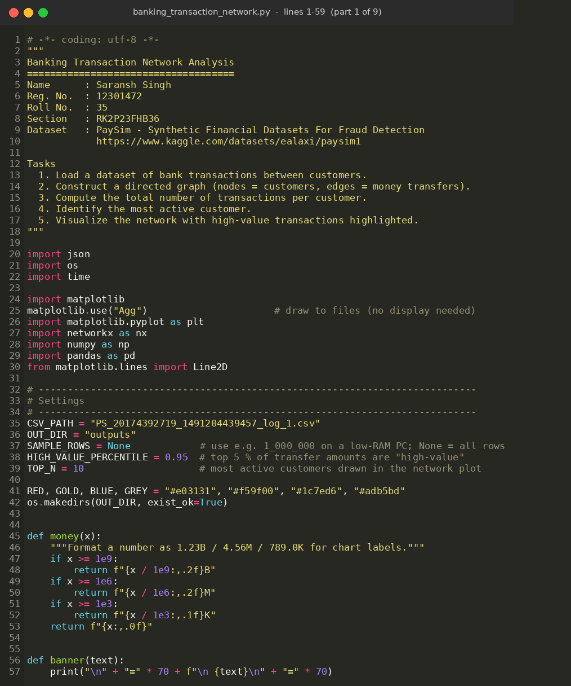
Figure 1: Source code – part 1 of 9
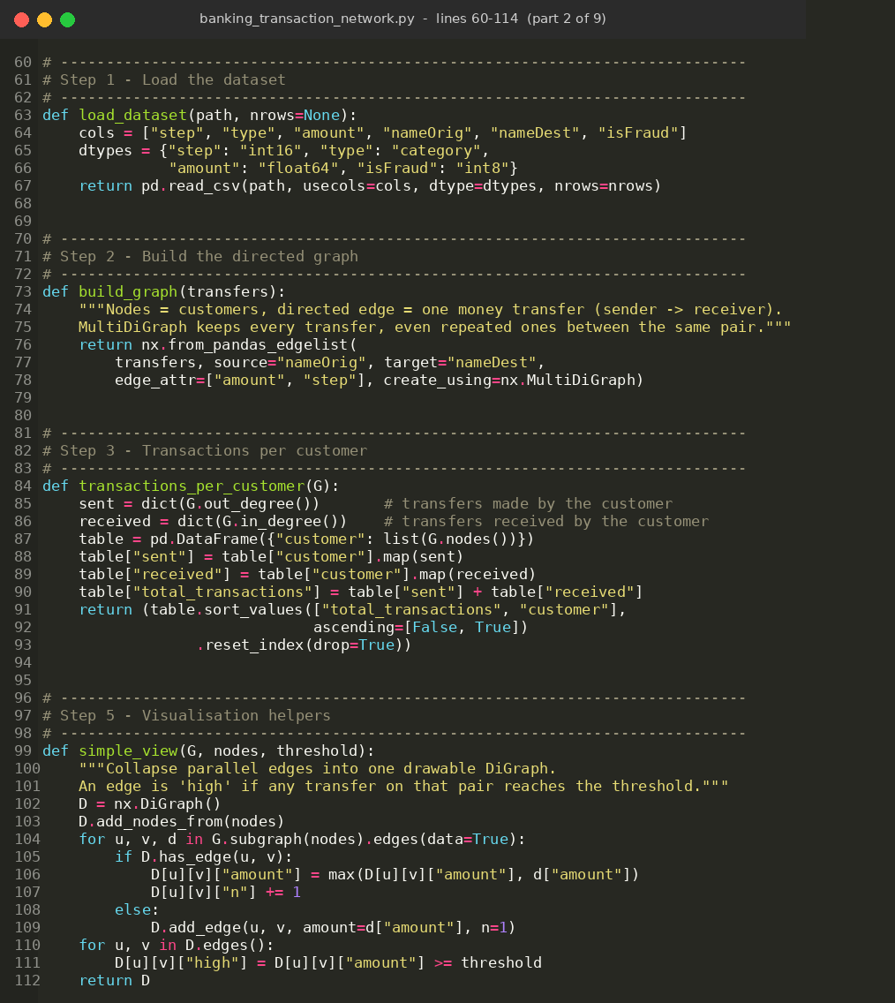
Figure 2: Source code – part 2 of 9
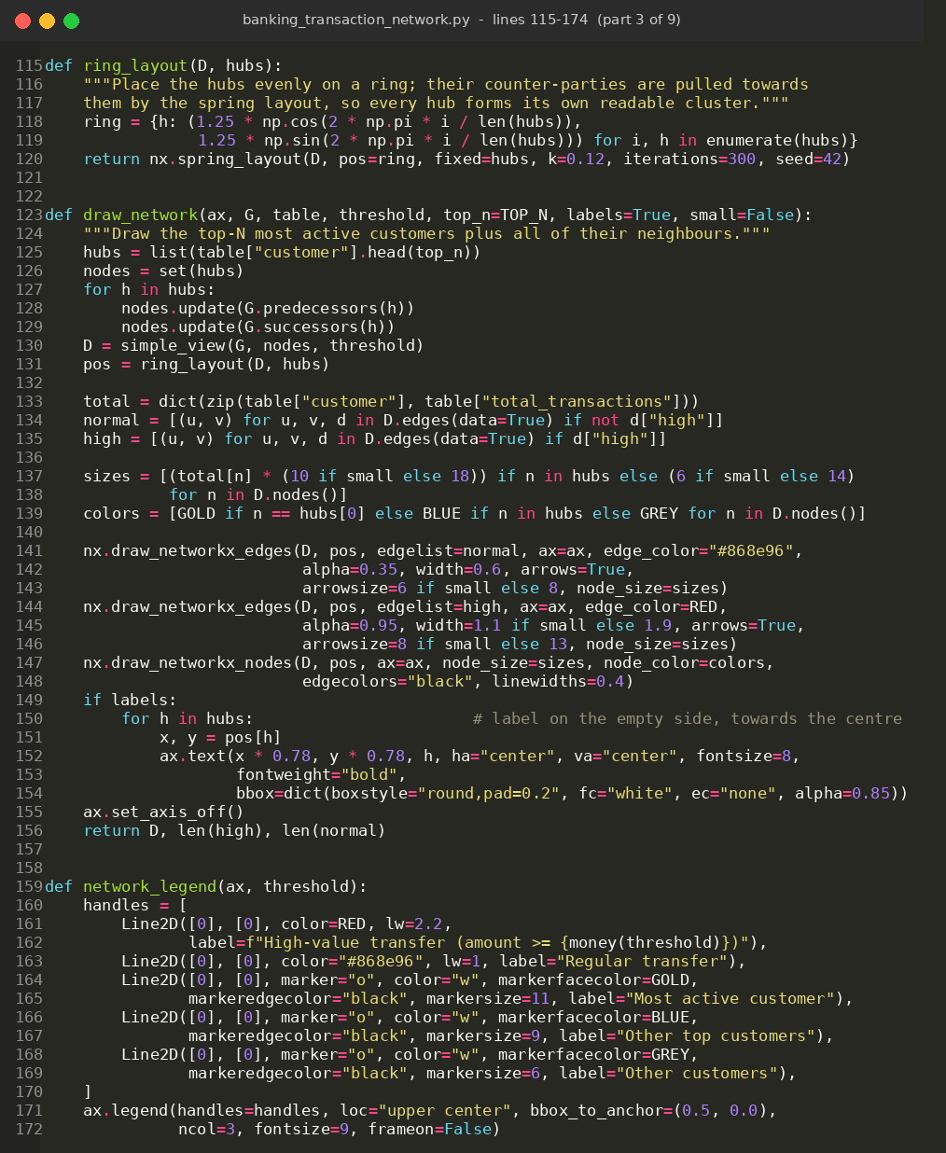
Figure 3: Source code – part 3 of 9
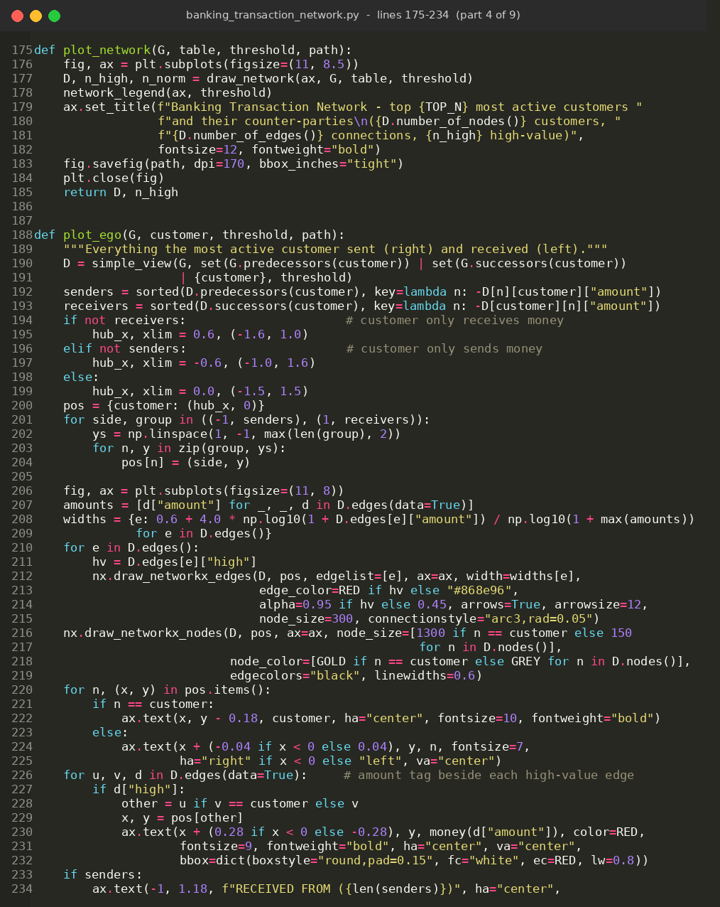
Figure 4: Source code – part 4 of 9
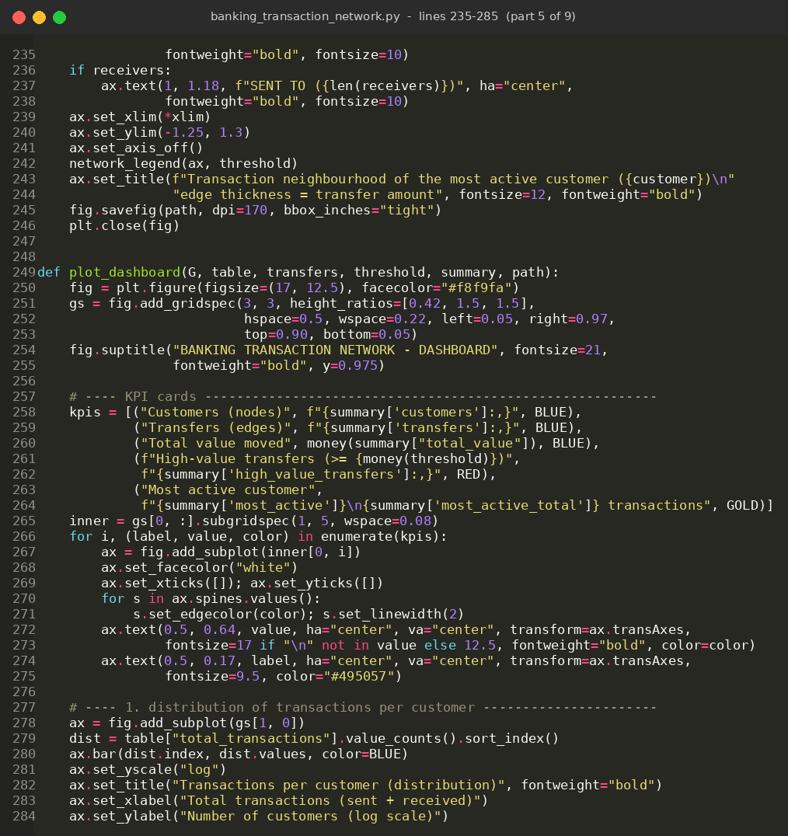
Figure 5: Source code – part 5 of 9
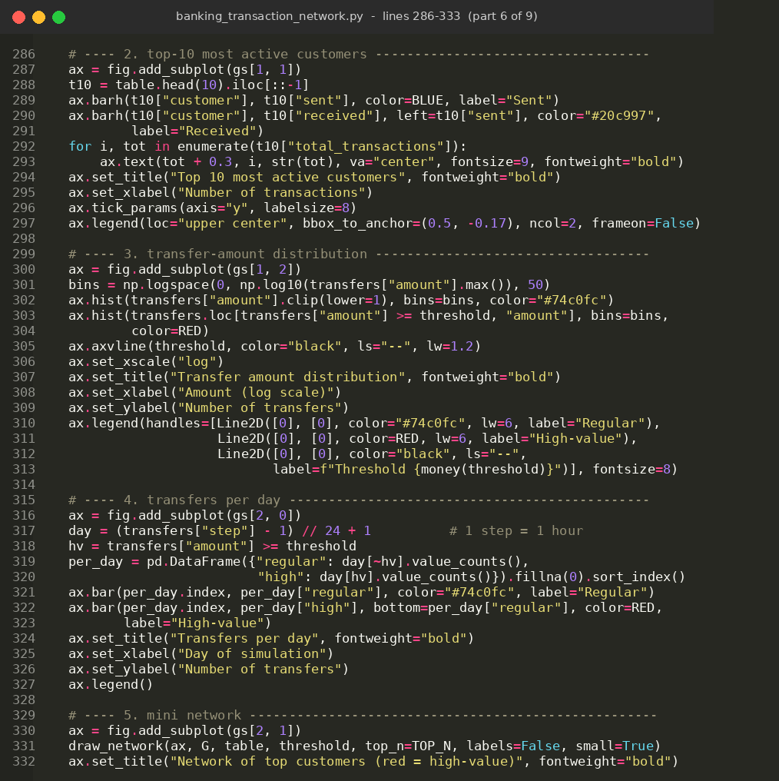
Figure 6: Source code – part 6 of 9
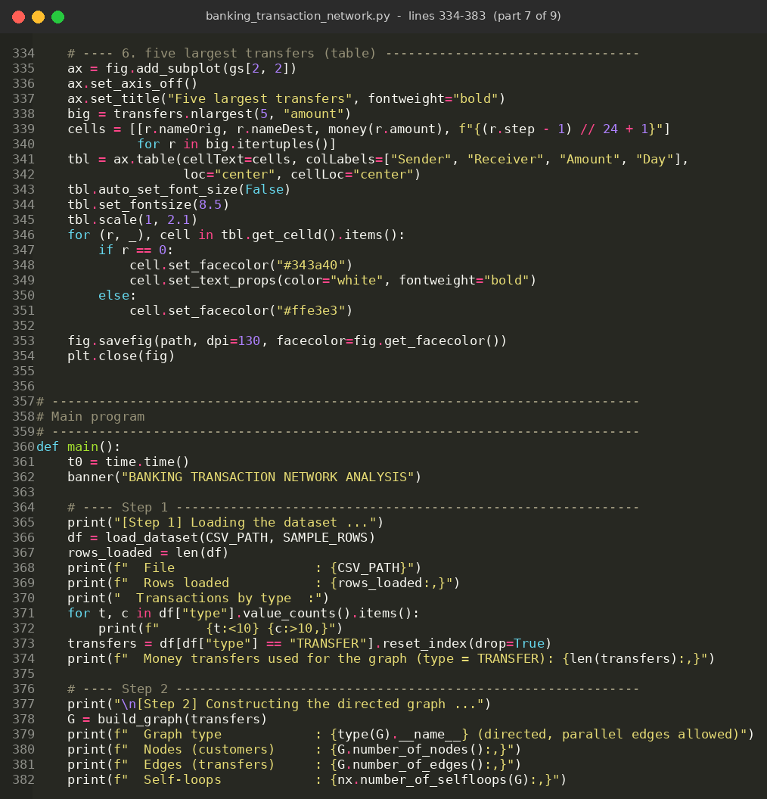
Figure 7: Source code – part 7 of 9
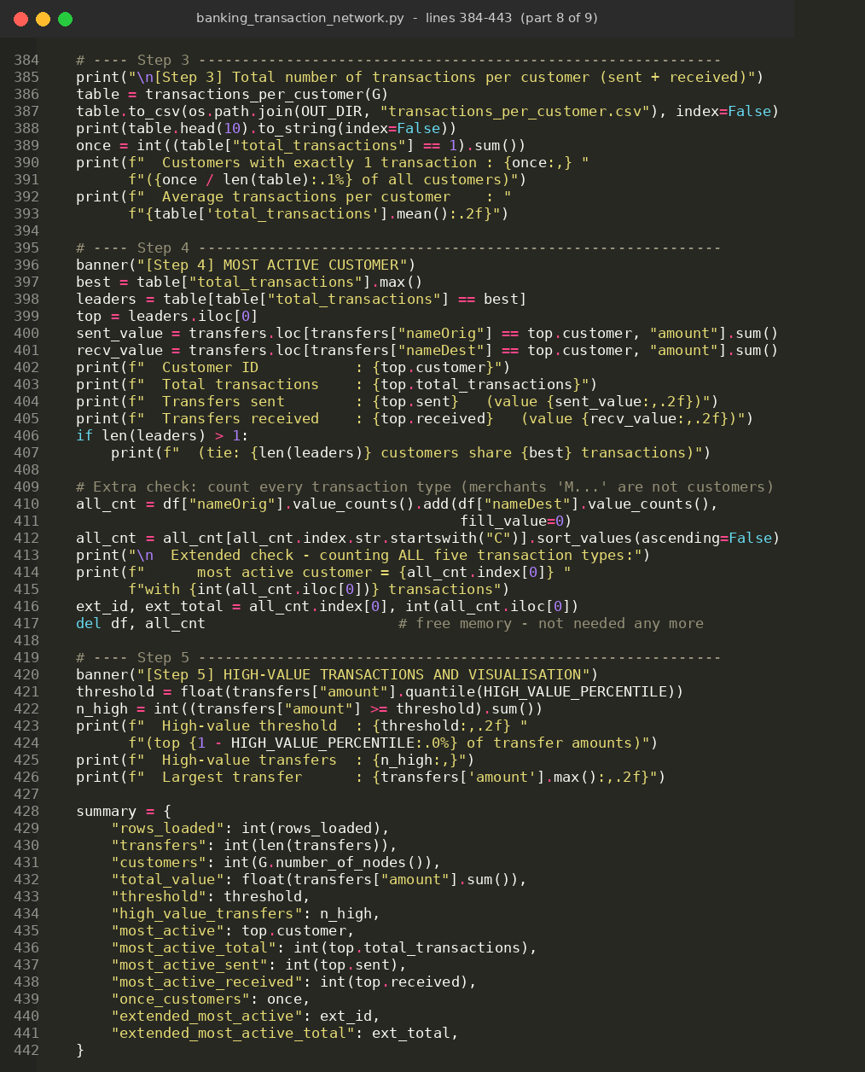
Figure 8: Source code – part 8 of 9
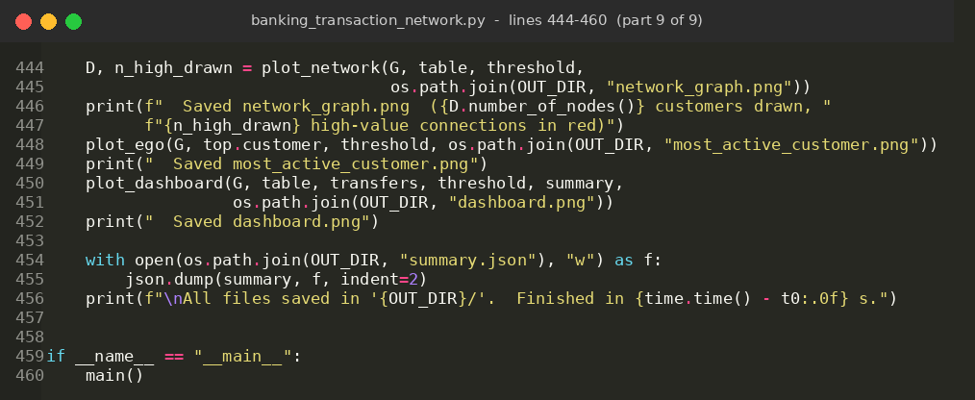
Figure 9: Source code – part 9 of 9

5. Output Screenshot

5.1 Console output
The program prints the result of every step. Figures 10 and 11 show the output when run on the full dataset.
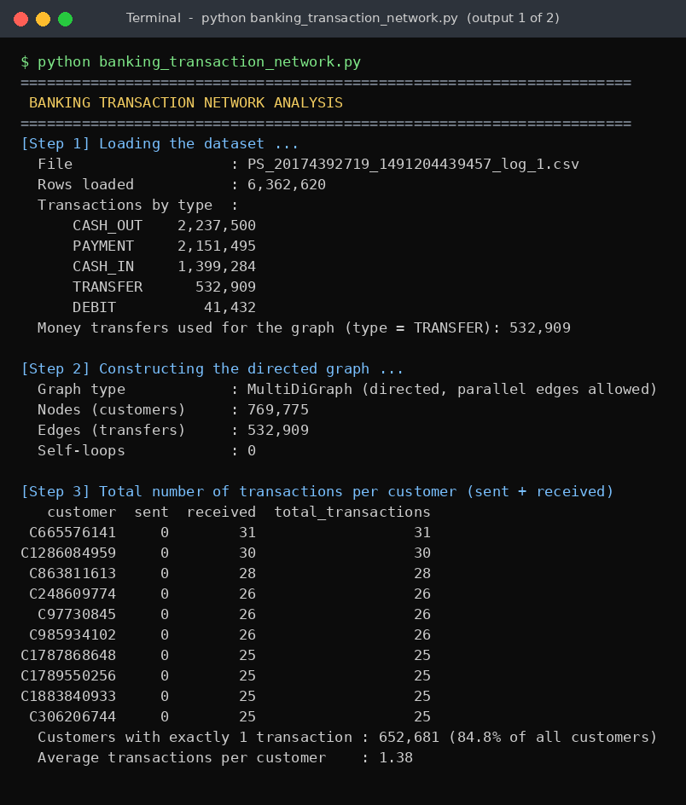
Figure 10: Console output – Steps 1 to 3 (loading, graph construction, transactions per customer)
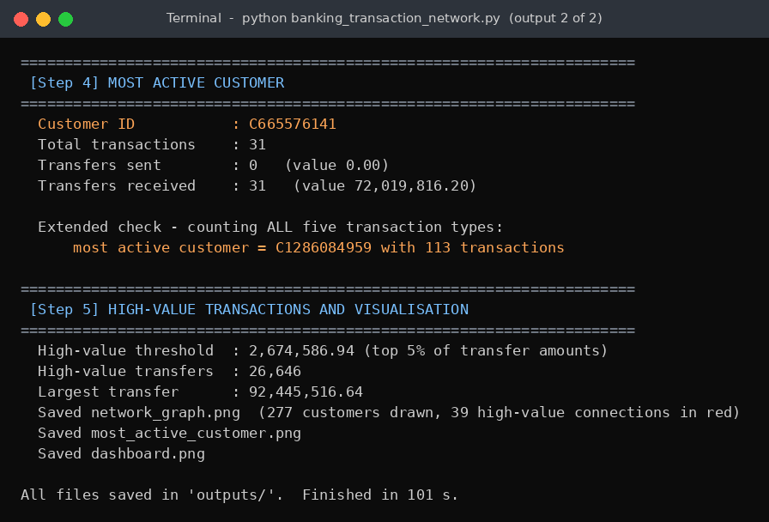
Figure 11: Console output – Steps 4 and 5 (most active customer, high-value transfers)

5.2 Summary of results
Measure | Result
Rows loaded from the CSV | 6,362,620
Customers (nodes) | 769,775
Money transfers (edges) | 532,909
Self-loops | 0
Customers with exactly 1 transaction | 652,681 (84.8%)
Average transactions per customer | 1.38
Most active customer | C665576141 – 31 transactions
transfers sent / received | 0 / 31
total value received | 72,019,816.20
High-value threshold (95th percentile) | 2,674,586.94
High-value transfers | 26,646
Largest single transfer | 92,445,516.64 (C1715283297 → C439737079, day 12)

Most active customer: C665576141 took part in 31 transactions – the highest in the transfer network. All 31 were received, none sent. Three of them are high-value (23,105,862.44; 20,418,755.82 and 3,231,928.32).
Extended check: if all five transaction types are counted instead of only transfers, the most active customer is C1286084959 with 113 transactions (30 of them are transfers, which is why it is second in the transfer network).

5.3 Transaction network with high-value transfers highlighted
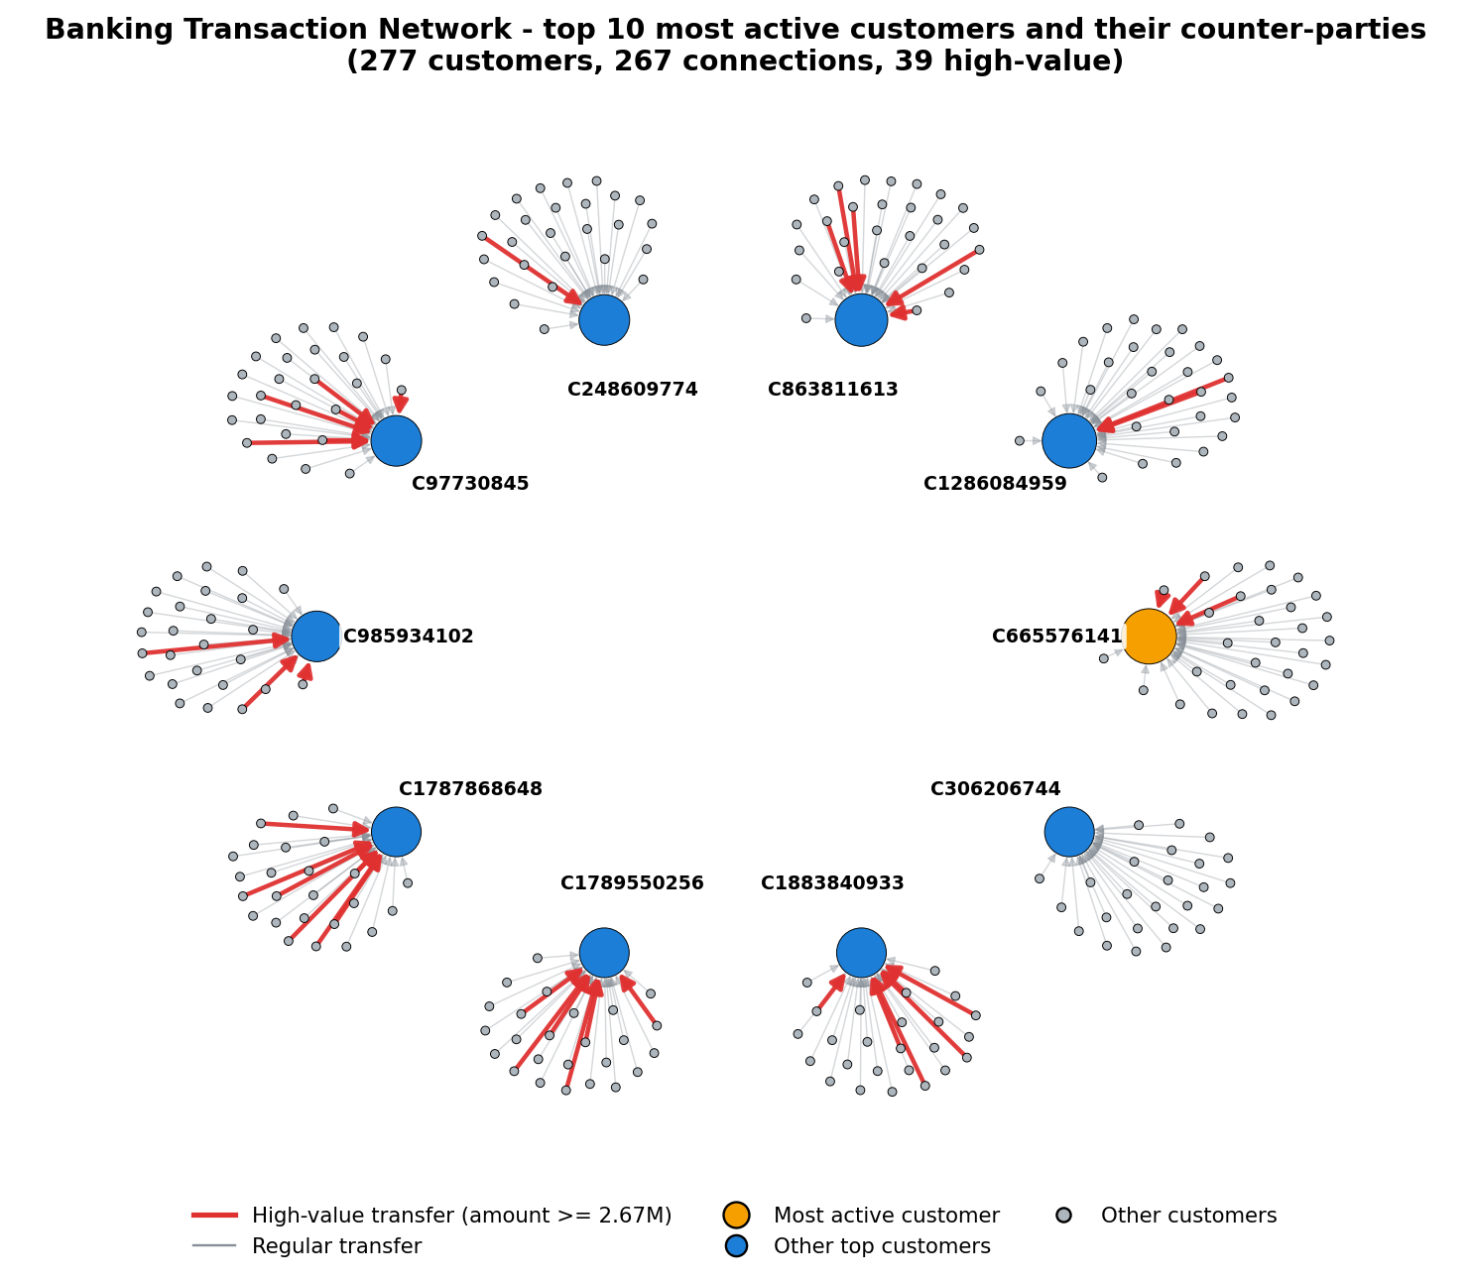
Figure 12: Network of the 10 most active customers and their counter-parties. Red thick arrows = high-value transfers; grey arrows = regular transfers; gold node = most active customer
Each blue/gold node is one of the ten most active customers and the small grey nodes are the customers who sent them money. The arrows point towards the hubs, which shows that these customers are collectors of money. 39 of the 267 connections drawn are high-value (red). Some hubs, such as C1787868648 and C97730745, receive mostly large transfers, while others, such as C306206744, receive almost only regular ones.

5.4 Neighbourhood of the most active customer
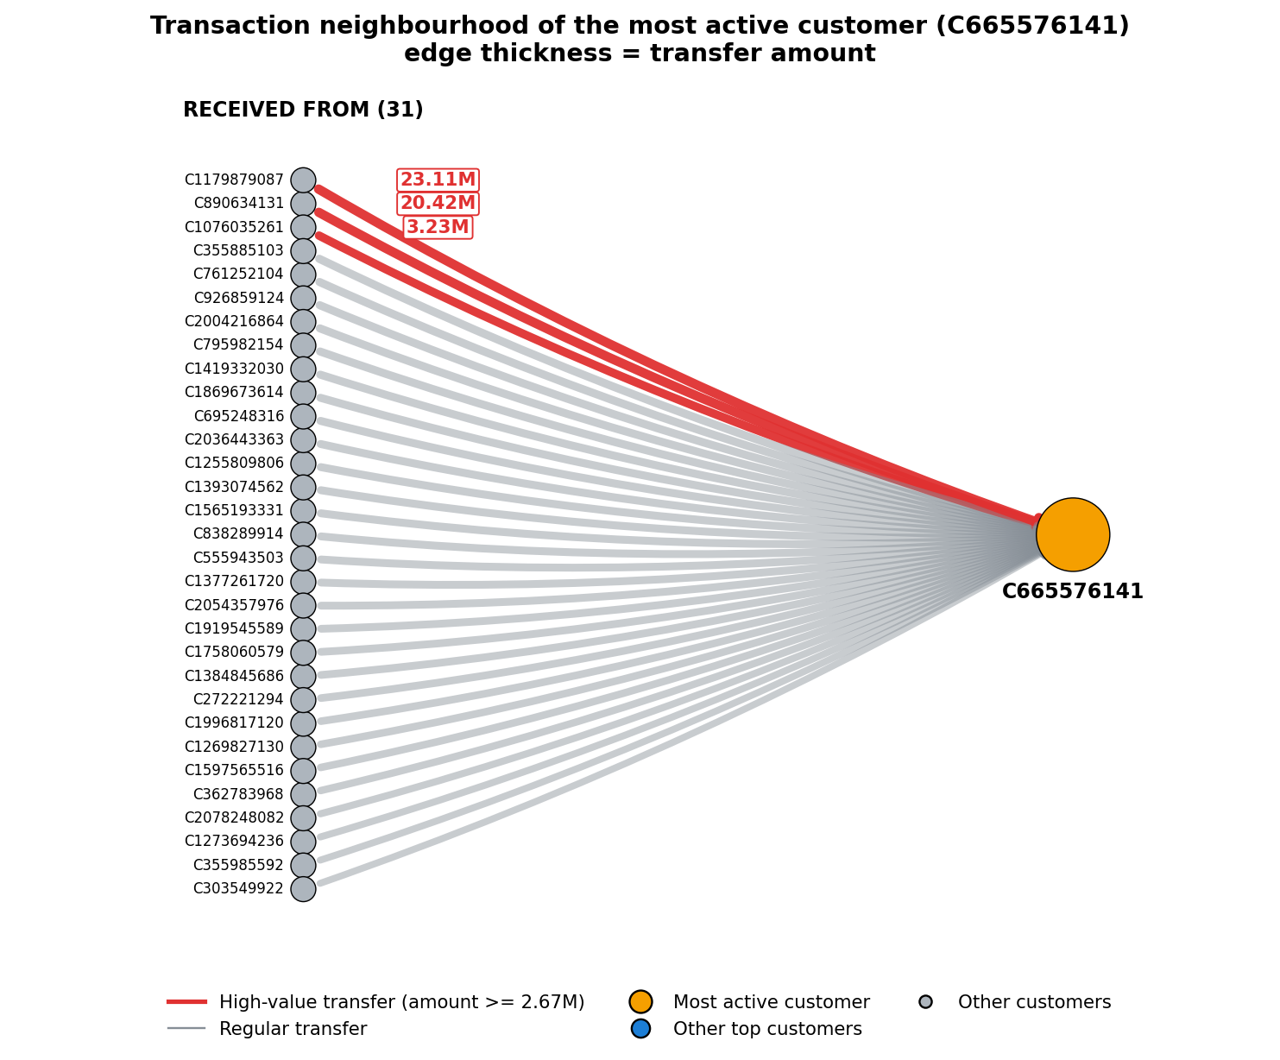
Figure 13: All 31 transfers received by C665576141 – edge thickness is proportional to the amount; high-value transfers are red and labelled
Three senders account for 46.76 million of the 72.02 million received (about 65%), so the customer’s value comes from a few very large transfers on top of many ordinary ones.

6. Dashboard
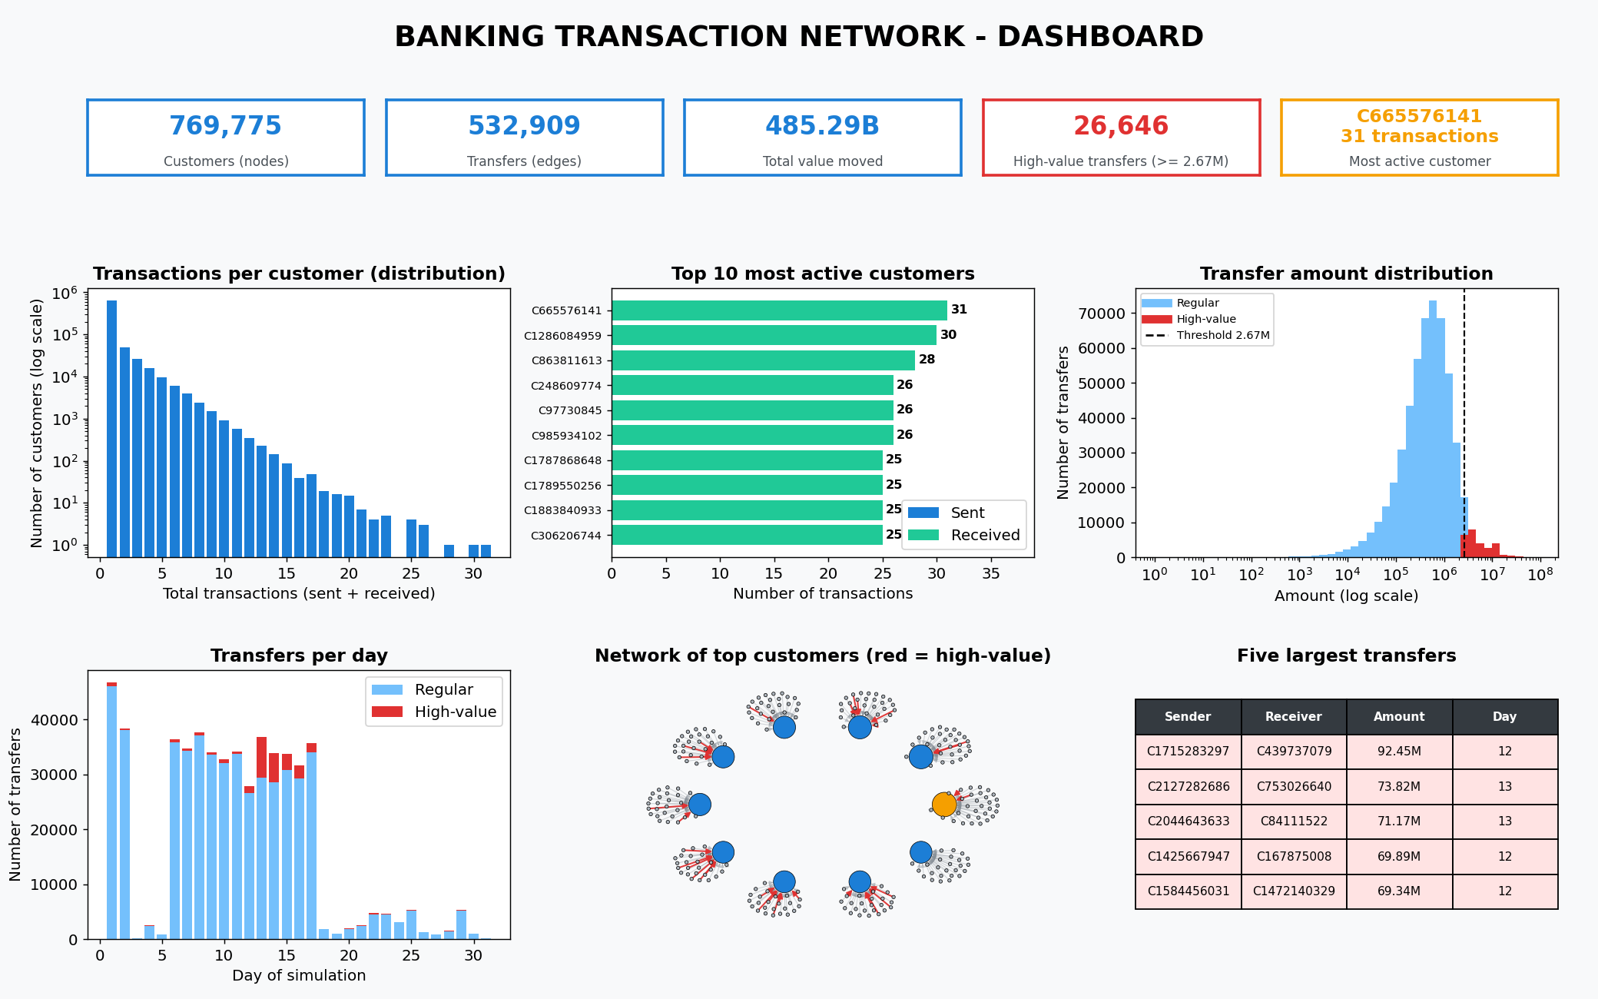
Figure 14: Dashboard – key figures, activity distribution, top-10 customers, amount distribution, daily activity, network overview and the five largest transfers

Dashboard insights
- Activity is highly concentrated. 84.8% of customers appear in only one transaction, but a few customers take part in 25–31.
- Top customers are pure receivers. All ten most active customers sent 0 transfers and only received money, a typical pattern of collection accounts. Only 70 customers in the whole dataset both sent and received money.
- Amounts are right-skewed. The median transfer is 486,308 while the mean is 910,647 – a few huge transfers pull the average up. The high-value threshold of 2.67 million separates the top 5%.
- Time pattern. 93.4% of all transfers happen in the first 17 days. High-value transfers peak between days 12 and 17 (78.6% of all of them); on day 13 about 20% of transfers were high-value compared with roughly 1% on days 1–2.
- Largest transfer. 92.45 million from C1715283297 to C439737079 on day 12.

7. Conclusion
A directed graph was built from 532,909 money transfers between 769,775 customers of the PaySim banking dataset. Counting in-degree and out-degree gave the number of transactions for each customer; the most active customer is C665576141 with 31 transactions. The network drawing and the dashboard highlight the top 5% of transfers (at least 2.67 million) in red and show that the busiest accounts are mostly receivers and that large transfers cluster in the middle of the simulated month. The same program can be re-used for another transaction file or for another high-value rule by changing the settings at the top of the script.

8. References
- PaySim dataset on Kaggle: https://www.kaggle.com/datasets/ealaxi/paysim1
- E. A. Lopez-Rojas, A. Elmir and S. Axelsson, “PaySim: A financial mobile money simulator for fraud detection”, 28th European Modeling and Simulation Symposium (EMSS), Larnaca, Cyprus, 2016.
- NetworkX documentation: https://networkx.org/documentation/stable/
- pandas documentation: https://pandas.pydata.org/docs/
- Matplotlib documentation: https://matplotlib.org/stable/

